Automobile Shipping Quote Requirements

In order to provide you with an accurate quote please provide us with the following information
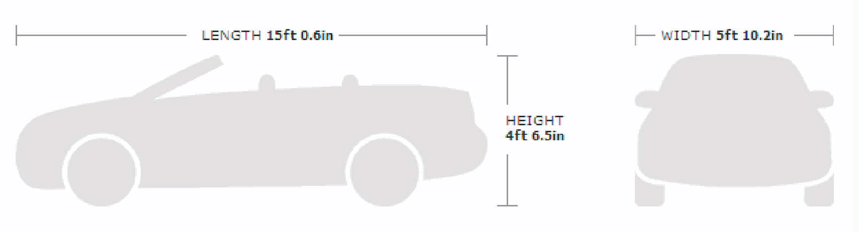
- Exterior Measurements:
Sample: Width 5 ft. 10.2” or (70.2 Inches) (Mirror to Mirror)
Length 15 ft. 0.6” or (180.6 Inches) (Bumper to Bumper)
Height 4 ft. 6.5” or ( 54.5 inches) (Floor to top of Vehicle)
- Value: Value is Need to quote insurance. *see requirements below*

- Rate will be based on vehicle being loaded inside the container in our warehouse. If vehicle requires towing from a dealer to our warehouse, please let us know in order to quote accordingly based on the location of the vehicle.

- Automobile must be in working condition for this rate to apply.

- Quote will include charges from our warehouse to Grand Cayman Port. Destination charges such as Cayman Duties, Port Authority, Customs clearance, Licensing, etc are not quoted by Deluxe Freight. If such information is required you must consult our Cayman Island Customs Agency.
Additional Requirements (not required for quote but required to export from the US)
- Original Title (Copies will NOT be accepted)
- Original Signed & Notarized Power of Attorney
- Buyers Government Picture ID
- Bill of Sale (if applicable)
- All Documents must be signed with BLUE ink
- Vehicle must be in working condition
- Vehicle must have less than a ¼ tank of gas in order to be exported
- In order for your vehicle to be transported with insurance, it cannot be older than 10 model years
NOTE
Vehicle will be subject to a 72 hour hold after Delivery and US Customs clearance
Additional cargo/items may NOT be transported inside the vehicle

